**Title of Manuscript (Concise and Informative, Font Size 14)**

Author1, Author2, Author3*

Affiliation of Author 1 …………

Affiliation of Author 2 …………

Affiliation of Author 3 …………

Email, Orcid Id of all Authors

*Corresponding Author

**Abstract**

Provide a concise and factual abstract (up to 300 words) stating briefly the purpose of the research, principal results, and major conclusions. The abstract must stand alone and should avoid references and uncommon abbreviations unless defined within.

**Keywords**

Provide 4–6 keywords for better visibility and discoverability.

**1. Introduction**

Provide the background, objectives, and significance of the study. Clearly state the research problem and hypothesis, if applicable.

**2. Materials and Methods**

Describe the experimental setup, data collection procedures, analytical techniques, and methodologies used. Ensure sufficient details for reproducibility. Table 1 shows the data……………..

Table 1: The data………………………….

|  |  |  |  |
| --- | --- | --- | --- |
| a | b | c | d |
| P |  |  |  |
| Q |  |  |  |
| R |  |  |  |
| S |  |  |  |

**3. Results and Discussion**

Present the research findings with supporting tables, figures, and statistical analyses. Interpret results, discuss their implications, compare with previous research, and mention any limitations. Fig. 1 and 2 shows ……………………..

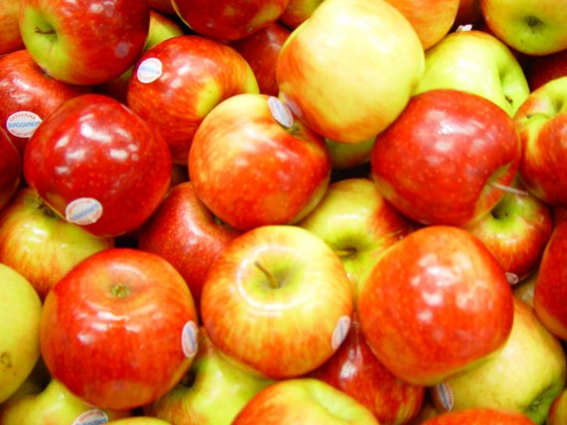

Fig. 1…………………..

Fig. 2…………………..

Table 2 indicates ……………..

Table 2: ………………………….

|  |  |  |  |
| --- | --- | --- | --- |
| a | b | c | d |
| P |  |  |  |
| Q |  |  |  |
| R |  |  |  |
| S |  |  |  |

**4. Conclusion**

Summarize the key findings of the study. Highlight the major contributions and suggest future research directions.

**Acknowledgement**

Mention individuals, organizations, or funding bodies that contributed to the research.

Funding

Specify the funding sources that supported the research.

**Statements and Declarations**

**Ethical Statement**: Confirm adherence to ethical guidelines (if applicable).

**Conflict of Interest**: Declare any conflicts of interest.

**Data Availability**: Provide information on data sharing and accessibility.

**Author Contributions:** Specify each author’s contributions.

**References**

Use numbered references in square brackets, e.g., [1], [2] in the text.

***Reference List***

Journal Article: Author(s), Year. Title. Journal Name, Volume(Issue), Page no. DOI

Book: Author(s), Year. Title. Publisher, Location.

Chapter in Edited Book: Author(s), Year. Title. In Book Title, Publisher, Pages.

Figures and Tables

Figures: High-resolution images (300 dpi or higher) in JPEG, PNG, or TIFF formats.

Tables: Editable text (not images).

Captions: Clear and descriptive captions for all figures and tables.

**Submission Guidelines:**

Manuscripts must be in Microsoft Word (2017 or later), single-spaced, Times New Roman, size 12, with 1-inch margins (Top, Bottom, Left & Right).

Levels of headings are allowed only up to three e.g.

**2. Materials and Methods**

**2.1 2nd level of heading**

**2.1.1 3rd level of heading**